Water & Sewer Service to Detached Accessory Structures
When water and sewer service is requested for a detached accessory building, separate water and sewer connections to the District mains may be required unless the accessory structure has been permitted as an Accessory Dwelling Unit (ADU) by the City of Lakewood or Jefferson County.

A building is an ADU when:
The dwelling unit is detached from the primary residence and contain facilities for sleeping, cooking, and sanitation and in which one or more persons could reasonably reside on a permanent and non-transient basis. Cooking facilities include any or all, of the following: sink, range, stove, conventional oven, microwave oven. Sanitation facilities include any or all, of the following: toilet, bath, shower. In addition, the property must not be sub-divided.
If the structure is considered an ADU:
- A separate sewer service connection is required. The service line is subject to Metro Water Recovery and Bancroft Clover’s standard connection fee for 1 single family residential equivalent (SFRE)

- The additional unit may be connected to the primary residence’s water service. The additional connection is subject to Denver Water’s connection fee for 1 ADU and Bancroft Clover’s connection fee for 1 additional multi-family unit.
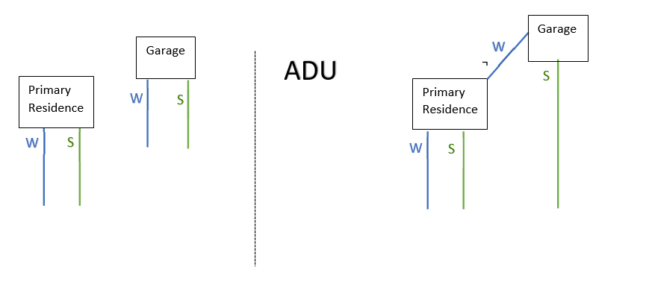

REFERENCES

Bancroft Water & Sanitation District Rules & Regulations, Adopted February 9, 2015 Section 800.01
Metro Water Recovery Rules & Regulations, Adopted January 17, 2023
Section 7.4
Denver Water Operating Rules, Amended June 9, 2021 Section 2.06 c

.


Planning Department

Civic Center North
470 South Allison Parkway Lakewood, Colorado 80226-3127
303.987.7505
303.987.7057 TTY/TDD
Lakewood.org/Planning

Zoning Summary for Accessory Dwelling Units in Residential Zone Districts

Accessory dwelling units (ADUs) are subordinate (smaller & ancillary) residential units, located on the same lot as a single-family dwelling unit; and may be either attached or detached. The following table explains the general requirements and process for building an ADU, as listed in Section 17.4.3.1.A of the Lakewood Zoning Ordinance. No variance or waiver may be requested for the property to allow an ADU.

PLANNING CRITERIA AND INFORMATION:

Site Requirements | ADUs are allowed in most residential zone districts; check the use table in Article 4.1 of the Lakewood Zoning Ordinance for confirmation.  Minimum lot size: 9,000 square feet, regardless of zone district.
s | ADUs must comply with all primary structure dimensional standards for the applicable zone district, and may not be located in front of the primary dwelling unit.  Maximum height: 30 feet for a detached Accessory Dwelling Unit.
Owner Occupancy | The owner of the property must live in either the primary or accessory dwelling unit.  The owner shall record an Owner Occupancy Certificate with Jefferson County, and the covenant shall run with the property (see attached example). Please submit a recorded copy of the certification just prior to receiving your building permit.
Design Requirements | ADUs cannot exceed 700 square feet of gross floor area or contain more than one bedroom. Only one ADU is permitted per lot.  The exterior of ADUs must be similar in appearance to the primary dwelling unit, including but not limited to materials, color, roof pitch, and detailing.  ADUs are subject to the minor site plan process outlined in Article 2, and the general design and development standards in Articles 6 and 7. Waivers and variances will not be granted for ADUs.
Parking | Applicants must provide a minimum of one, but not more than two, off-street parking spaces for the ADU in addition to the off-street parking provided for the primary residence. Please label the parking spaces on your site plan with your building permit.
Next Steps | - Check with your Water and Sewer District for ADU requirements  - Check with the building department for associated building code regulations  - Submit the ADU Supplemental Zoning Review Form  - Prepare construction drawings and submit for a building permit  - Before building permit approval, submit a recorded Owner Occupancy Certificate
This informational handout is intended to provide a clarification of the Lakewood Zoning Ordinance and may only be used as a guiding document. The complete Zoning Ordinance is available online at www.lakewood.org/zoning.

Revised 06/20/2017

